# CSC8503 – Coursework Documentation

## Features:

* Friction
* AI Pathfinding
* Grappling Hook
* Hinged doors
* Pushdown Automata to pause and restart the game
* OBB collisions
* Ability to win or lose game

## Controls:

Left click on Green Goat and keypress L to lock onto it. Use WASD to move and spacebar to jump. Use right click to grapple onto objects and swing about. Use spacebar to undo grapple.

Press P to pause and U to unpause. Press F1 and then spacebar to restart game or F1 and escape to quit the game.

### A.I. Pathfinding

### Grappling Hook

### Hinged doors

### Pushdown Automata to pause and restart the game

### OBB collisions

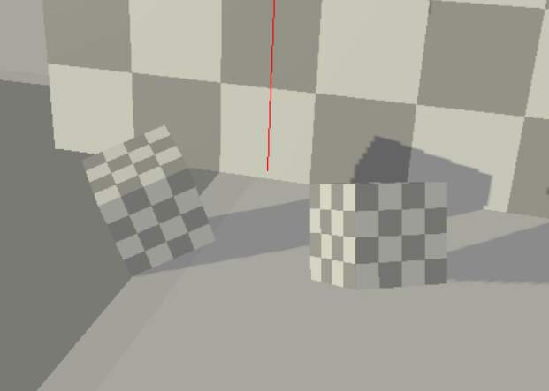

### Ability to win or lose game

